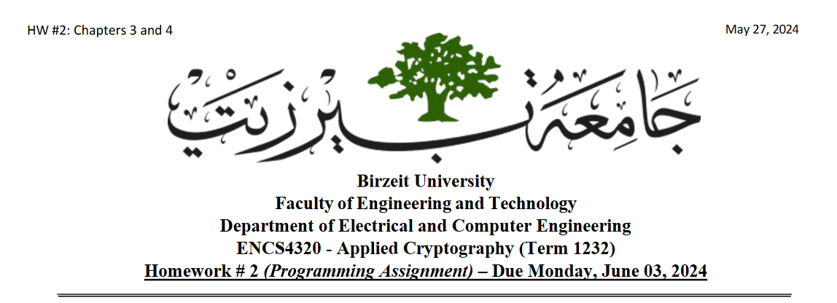

Original photo to encrypt:

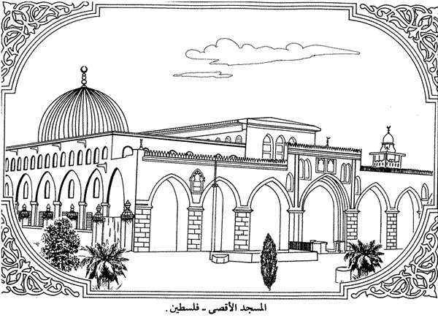

Figure :original photo

ECB TEA:

Encryption:

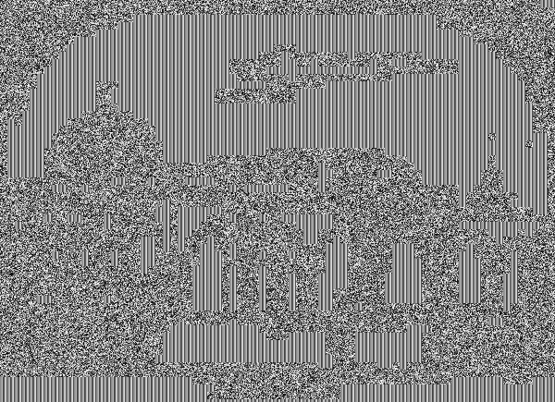

Figure :ecb TEA encryption

Decrypted:

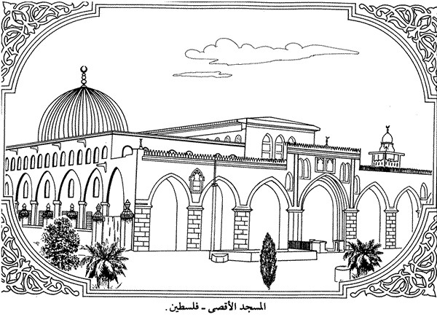

Figure :ecb TEA decrypted

CBC TEA:

Encryption:

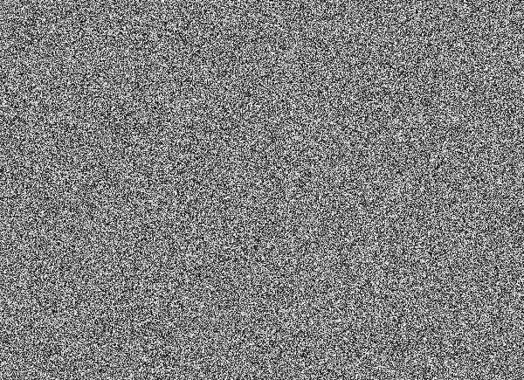

Figure :CBC TEA encryption

Decrypted as whole:

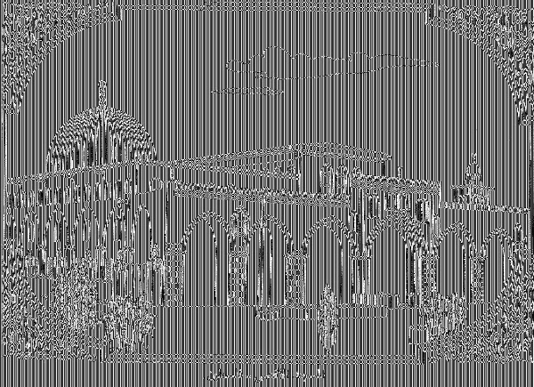

Figure :CBC TEA decryption

Decrypted with original header (didn’t encrypt first 640 bits):

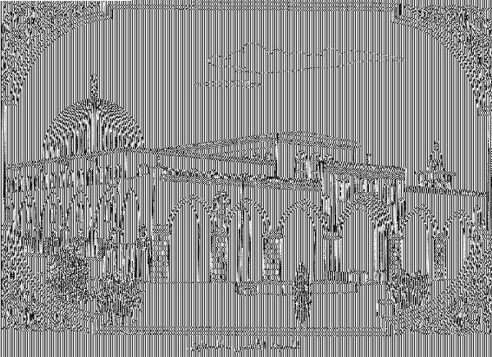

Figure : CBC encryption attempt 2

Miral Issa

1200527